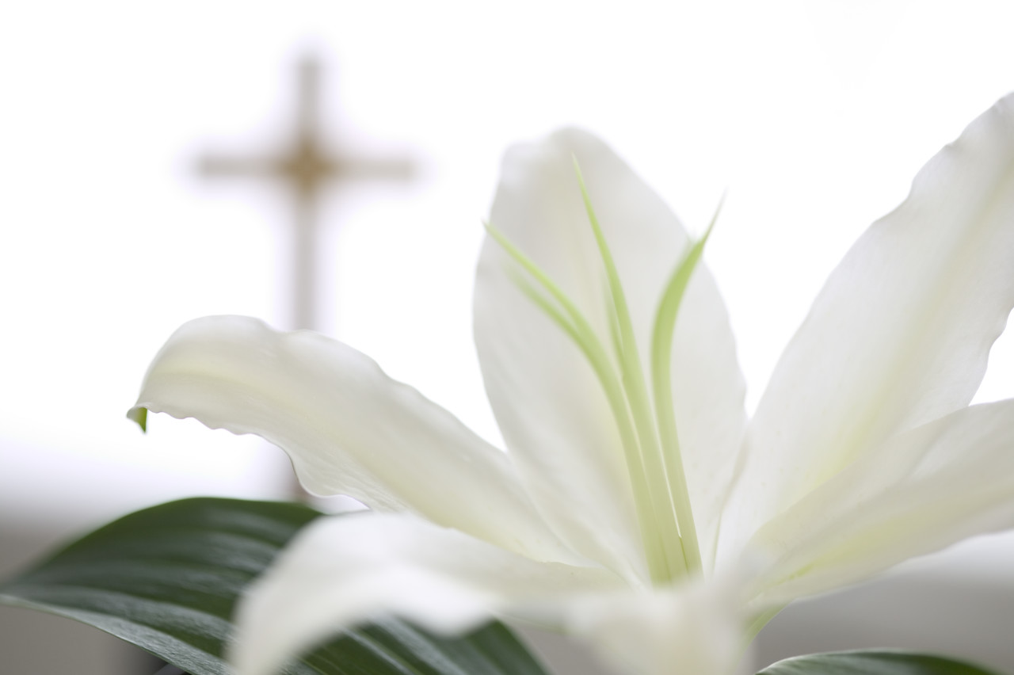HOLY WEEK SCHEDULE

Wednesday, April 16 ~ Confessions

4:45 – 5:30 p.m.

Stations of the Cross

5:30 p.m.

Holy Thursday, April 17 ~ Mass of the Last Supper

5:30 pm

Good Friday, April 18 ~ Passion of the Lord

5:30 p.m.

Easter Sunday, April 20 ~ Mass of the Resurrection of the Lord

11:00 a.m.